Question 1 Standard: A1.APR.A.1 Blooms: Apply DOK: 1 Total Points: 5
Points Scored:
Points Possible: 49
---------- = %
Perform the following operation on the polynomials as instructed below:
(4x³ – 3x² + 5x – 7) – (–2x³ + 5x² – 2)
Show ALL work necessary (4 points):

Answer (1 point):

Question 2 Standard: A1.APR.A.1 Blooms: Apply DOK: 1 Total Points: 5
Perform the following operation on the polynomials as instructed below:
(5x³ + 2x² + 3x – 9) + (–4x³ – 3x² + 5)
Show ALL work necessary (4 points):

Answer (1 point):

Question 3 Standard: A1.SSE.A.2 Blooms: Apply DOK: 1 Total Points: 5
Perform the following operation on the polynomials as instructed below:
(2x³ + 3x² + 4x – 5)(–4x² – 2x + 7)
Show ALL work necessary (4 points):

Answer (1 point):

Question 4 Standard: A1.APR.A.1 Blooms: Analyze DOK: 2 Total Points: 3
Perform the necessary operations to convert the form of the expression below to an equivalent expression from the list shown below… select the appropriate choice by circling:
(a²y)^{1/2} (b⁶c⁴)^{1/3}

- ab²c c) ab²c √y ³√c
- ab³c √cy d) ab³c²
Show ALL work necessary (2 points):

Answer (1 point):

Question 5 Standard: A1.APR.A.2 Blooms: Apply DOK: 1 Total Points: 5
Perform the following operation on the polynomials as instructed below:
(x³ + x² – 19x + 21) ÷ (x – 3)
Show ALL work necessary (4 points):

Answer (1 point):

Question 6 Standard: A1.APR.A.2 Blooms: Apply DOK: 2 Total Points: 5
Perform the necessary operation to simplify the rational expression shown below:
(x² + 2x – 63)
(x – 7)
Show ALL work necessary (4 points):

Answer (1 point):

Question 7 Standard: A1.CED.A.4 Blooms: Analyze DOK: 2 Total Points: 5
Ohm’s Law is the equation V = ( I )(R), where v = voltage, I = current (Amps), and R = resistance… solve this equation for “current” in the space provided below:
Show ALL work necessary (2 points):

Answer (1 point):

Question 8 Standard: A1.REI.B.4 Blooms: Analyze DOK: 2 Total Points: 8
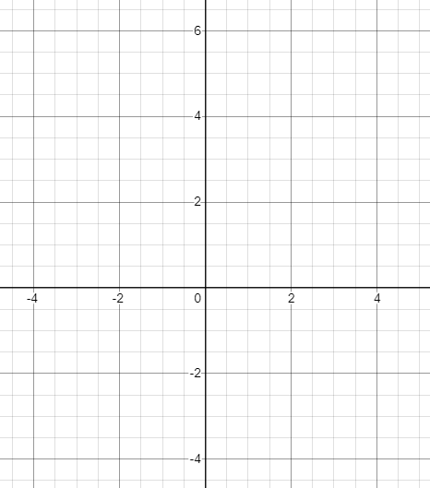
Graph and label the following functions on the SAME axis coordinate below:
y = 2x + 1
y = –x² + 4x + 1
Show ALL work necessary (2 points):

Question 9 Standard: A1.CED.A.4 Blooms: Analyze DOK: 2 Total Points: 4
Solve the following system of equations algebraically to find the solution points below:
y = 2x + 1
y = –x² + 4x + 1
Show ALL work necessary (2 points):

Answer (2 points): ( , ) and ( , )

Question 10 Standard: 8.EEI.C.2 Blooms: Analyze DOK: 2 Total Points: 4
Solve the following system of equations by your choice of methods to find the solution points below:
y = ⅓ x + 3
x – 3y = – 9
Show ALL work necessary (2 points):

Answer (1 points):

