Question 1 Standard: A1.LQE.A.2 Blooms: Apply DOK: 2 Total Points: 5
Points Scored:
Points Possible: 34
---------- = %
Find the vertex, the equation of the axis of symmetry, and the y-intercept for the function below:
y = 2x² + 4x - 3
Show ALL work here (2 points):

Answers (1 point each):
Vertex:
Axis of Symmetry:
y-intercept:

Question 2 Standard: A1.IF.B.3 Blooms: Analyze DOK: 1 Total Points: 6
Complete the table to graph and label the given function in the space provided below:
y = x² - 6x - 1
x | f(x)
-2
-1
0
1
2
Graph the function here (2 points): Use this table (1 points):
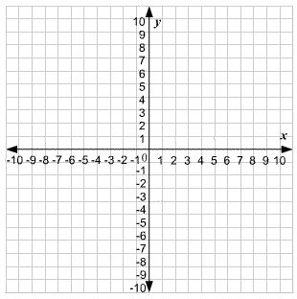

Answer these prompts (1 point each):
Vertex Coordinate:
Axis of Symmetry:
y-intercept coordinate:
Question 3 Standard: A1.BF.A.1 Blooms: Analyze DOK: 2 Total Points: 2
Give your explanation here (2 points):

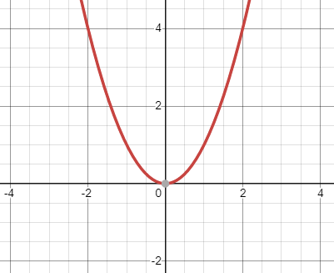
Describe in words how the function f(x) = x² (shown below) changes to become the function g(x) = (x-3)²:
f(x) = x²

Question 4 Standard: A1.IF.C.8 Blooms: Analyze DOK: 2 Total Points: 5
Work area:

Answer the prompts below (1 point each):
Vertex Coordinate:
Axis of Symmetry:
y-intercept coordinate:
Sketch the function g(x) = (x-3)² on the axis provided below:
f(x) = x²
Sketch your graph above (2 points)

Question 5 Standard: A1.LQE.A.1 Blooms: Analyze DOK: 2 Total Points: 6
Analyze the tables below and assess what type of function they represent:
Circle your choices and show all of your work in the spaces provided below:
x f(x)  -1 8  0 4  1 2  2 1  3 0.5  Circle one (1 point):  Exponential  Quadratic  Linear | x f(x)  -2 -8  -1 -3  0 2  1 7  2 12  Circle one (1 point):  Exponential  Quadratic  Linear | x f(x)  -2 8  -1 2  0 0  1 2  2 8  Circle one (1 point):  Exponential  Quadratic  Linear
Work/Rationale (1 points): | Work/Rationale (1 points): | Work/Rationale (1 points):

Question 6 Standard: A1.LQE.A.3 Blooms: Analyze DOK: 2 Total Points: 1
Analyze the table below and identify a function which best represents the data:
x | f(x)
-1 | 1
0 | 0
1 | 1
2 | 4
3 | 9

- Linear c) Exponential
- Quadratic d) Cubic

Question 7 Standard: 8.EEI.B Blooms: Analyze DOK: 2 Total Points: 2
Show ALL work necessary (1 points):

Answer (1 point):
Simplify the following exponential expression using the rules for exponents as your guide:
(5x²y)² (2xy²z)³ (4xyz²)

Question 8 Standard: 8.EEI.B Blooms: Analyze DOK: 2 Total Points: 3
Show ALL work necessary (2 points):

Answer (1 point):
Simplify the following exponential expression using the rules for exponents as your guide:
( )
2
b⁴c⁵
a⁻⁴ b⁻⁴ c³

Question 9 Standard: A1.NQ.A.1 Blooms: Analyze DOK: 2 Total Points: 2
Simplify the following exponential expression using the rules for exponents as your guide:
(16x²y⁴)^{1/2} (8x³y⁹z¹²)^{1/3}
Show ALL work necessary (1 points):

Answer (1 point):

Question 10 Standard: A1.IF.C.7 Blooms: Analyze DOK: 2 Total Points: 2
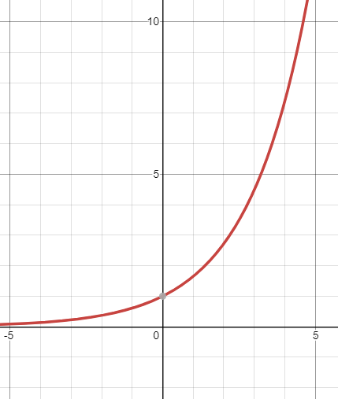
Given the following graphic, analyze and determine the function which best describes the shape:

Circle one choice only (1 point):
a) Linear
b) Quadratic
c) Exponential
d) Cubic

What is the y-intercept coordinates? (1 point)
Answer: ( , )

