Question 1 Standard: A1.REI.B.3 Blooms: Apply DOK: 2 Total Points: 6
Points Scored:
Points Possible: 68
---------- = %
Solve the System of Equation described below:
Negative three times one number plus five times another number is -11. Three times the first number plus seven times the second number is -1. Find the numbers.
Equation 1 (1 point):
Equation 2 (1 point):
Show ALL work here (2 points):

Answer (2 points): numbers = { , }

Question 2 Standard: A1.REI.B.5 Blooms: Apply DOK: 1 Total Points: 4
Solve the System of Equation described below:
4x – 4y = 8
-8x + y = 19
Show ALL work here (2 points):

Answer (2 points): (x, y) = ( , )

Question 3 Standard: A1.REI.C.6 Blooms: Understand DOK: 2 Total Points: 2
Is the following diagram representative of a “function” or a “relation”? Justify your answer below:
2
-3
-2
5
-1
5
3
-2
Circle your answer (1 point): Function Relation
Justify your conclusion FULLY (1 point):

Domain Range
Question 4 Standard: A1.REI.C.7 Blooms: Apply DOK: 2 Total Points: 7
Use the GRAPHING method to solve the System of Inequalities described below:
y < 5x - 2
y ≥ -6x + 2
Show ALL work here (5 points):
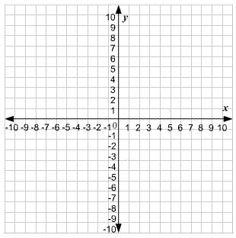

Student Scoring Guide:
Line 1 location (1 point)
Line 1 type (1 point)
Shaded Region 1 (1 point)

Line 2 location (1 point)
Line 2 type (1 point)
Shaded Region 2 (1 point)
Solution Region (1 point)

Question 5 Standard: A1.NQ.A.2 Blooms: Understand DOK: 1 Total Points: 3
Perform the indicated operations on the radical expression to represent it in its simplest form below:
√3(√6 + √2)
Show ALL work here (2 points):

Answer (1 point):
Question 6 Standard: A1.REI.C.6 Blooms: Apply DOK: 1 Total Points: 7
Graph the equation given below:
3x + 2y = 12
Show ALL work here (2 points):

Student Scoring Guide:
Point 1 location (1 point)
Point 1 Labeled (1 point)
Point 2 location (1 point)
Point 2 Labeled (1 point)

Line location (1 point)

Question 7 Standard: A1.LQE.A.3 Blooms: Apply DOK: 1 Total Points: 5
A music club began with an initial subscription list of 500,000 members. Since then, the subscription list has increased an average of 33,338 members per year. Write a function which describes the subscription c after t years and graph that function below:
Write your function here (2 points):

Student Scoring Guide:
y intercept location (1 point)
Plotted Slope (1 point)
Line drawn (1 point)
Axis drawn (1 point)
Axis labels/scale (1 point)
Question 8 Standard: A1.LQE.B.4 Blooms: Analyze DOK: 2 Total Points: 5
Given the table below, write the equation for the n^{th} term of arithmetic sequence and find the f(5) value below:
n | 1 | 2 | 3 | 4 | 5
f(n) | -12 | -8 | -4 | 0 | ?

Show ALL work here (2 points):

Equation (2 points): f(n) =
f(5) value (1 point): f(5) =

Question 9 Standard: A1.IF.A.1 Blooms: Apply DOK: 2 Total Points: 3
Determine whether the table below describes a function, and write the function/relation below:
n | -2 | -1 | 0 | 2 | 3 | 4
f(n) | 4 | 1 | 0 | 4 | 9 | 16

Circle your answer (1 point): Function Relation
Justify your conclusion FULLY (1 point):

Answer (1 point): f(n) =

Question 10 Standard: A1.IF.A.2 Blooms: Apply DOK: 2 Total Points: 4
If f(x) = 3x – 2 and g(x) = x² – 4x, find the values for f(5) and g(5) in the space provided below:
Show ALL work here (2 points):

f(5) value (1 point): f(5) =
g(5) value (1 point): g(5) =
Question 11 Standard: A1.IF.C.7 Blooms: Analyze DOK: 2 Total Points: 6
Graph the function y = 2x² + 2 and answer the questions about key features in the space given below:
Show ALL work here (2 points):

Student Scoring Guide (1 point each):
Write the VERTEX coordinate: ( , )
Write the AXIS of SYMMETERY: x = ______
Write the y-INTYERCEPT: ( , )
Are there any Real Zeros? Circle one: Yes No

Question 12 Standard: A1.IF.A.2 Blooms: Apply DOK: 2 Total Points: 8
Given the two functions represented below, answer the question prompts in the space given below:
Function A: Function B:
x | f(x)
-1 | 1
0 | 0
1 | 1
2 | 4
3 | 9
{ (0 ,3 ), (2 ,1 ), (4 ,-1 ), ( 6,-3 ), ( -2,5 ) }

Analysis (1 point each): | Rationale (1 point each):
- Are Functions A and B the SAME shape?  Circle one: Yes No | a)
- Function A is…  Circle one: Linear Quadratic | b)
- Function B is…  Circle one: Linear Quadratic | c)
- Which function has a “vertex”?  Circle one: A B | d)

Question 13 Standard: A1.BF.A.1 Blooms: Analyze DOK: 2 Total Points: 2
Explain the difference in the graphical shapes between f(x) = x² – 4x, and g(x) = x² – 4x + 3 below:
Answer and justify your conclusions FULLY here (2 points):

Question 14 Standard: A1.BF.A.1 Blooms: Understand DOK: 1 Total Points: 1
When a function “slides” on the coordinate axis, but does NOT change shape or orientation, this is referred to as a:

- Rotation c) Expansion
- Contraction d) Translation

Question 15 Standard: A1. BF.A.1 Blooms: Analyze DOK: 2 Total Points: 5
Given the function f(x) below… graph the transformation g(x) as instructed:
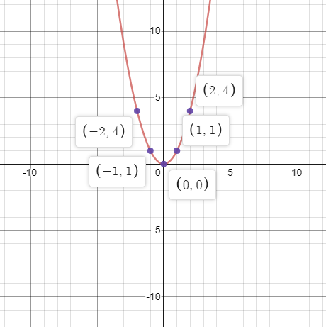
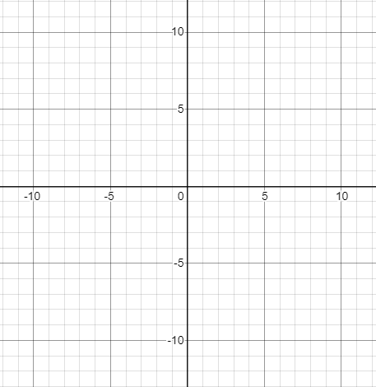

f(x) = x² g(x) = x² where: (x + 2, y - 1)

